VOTER PERSUASION ANALYTICS

Project Introduction
CiviSight Analytics was approached by a statewide political organization to support a data driven analysis for outreach planning for upcoming election cycle. They maintain a voter data set to determine how their message campaign affects the voters.
The client wants to know what type of voters are most likely to be influenced by campaign outreach. This information will help them make decisions regarding campaign outreach, such as where to send campaign workers, what type of content to send, and whom to prioritize. The solution also needs to be understandable for those who are not technically proficient.

Business and Analytical Goal

Business Goal
The main business objectives are to help the client organization make data-driven decisions regarding campaign outreach. The client runs a business in a changing environment, meaning decisions need to be made on a regular basis. The outreach of the campaign cannot be made to every voter, as this would not be feasible.
The objective of this project is to apply supervised machine learning to predict voter persuasion and determine if messages are effective on different segments of voters. This will help campaign leadership to make strategic decisions and design campaigns accordingly.

Analytics Goal
From an analytics point of view, our primary objective is to design and test supervised learning models that make predictions on voter persuasion outcomes using demographic, political, and behavioral factors. These models will be used for two primary objectives: identifying voters most likely to be persuaded and understanding the factors that influence persuasion.
The research question that will be addressed by the analytics is: Do campaign messages have varying effects on persuasion across voter segments? In order to answer this research question, we will analyze the effects of treatment across several segmentation variables such as party, age groupings, gender, voting history, political inclinations and demographic factors.

Data preprocessing

Dataset Overview
The voter persuasion dataset contains data of 10,000 voters and 78 attributes which covers the voter Id, demographics, political affiliations, voting history, neighborhood, campaign outcome. Each record represents a single voter which is identified by VOTER_ID.

Attribute Definition
- Target Variable:
The target variable is MOVED_A which is binary variable. Where 0 represents the voter is not persuaded and 1 represents the voter is persuaded. This variable directly aligns with the outcome of our goal.

- Treatment variables:
MESSAGE_A is the primary treatment variable which denotes the if the voter received the campaign message. 1 represents the message is received and 0 represents the message is not received by the voter.
MESSAGE_A_REV is the reverse of treatment variable MESSAGE_A and
I3 represents an additional treatment condition.

- Demographics
The dataset contains multiple demographic variables.
AGE – is the age of the voter.
GENDER_F AND GENDER_M – represents binary variables Female and Male respectively.
These variables are crucial to create and identify the segments.

- Political Affiliation:
Party affiliation is shown through 3 variables,
PARTY_D – Indicates if the voter is Democrat (1 = YES).
PARTY_R – Indicates if the voter is Republican (1 = YES).
PARTY_I – Indicates if the voter is Independent (1 = YES).
These variables are important dimensions of political identity and is likely a strong indicator of voting behavior. These help to understand the persuasion and the campaign effectiveness.

- Voting History:
Voting history is represented by several turnout variables. General election turnout variables include VG_04, VG_06, VG_08, VG_10, and VG_12, corresponding to turnout in the 2004, 2006, 2008, 2010, and 2012 general elections, respectively. Participation in the presidential primary election in 2008 and 2012 is represented by VPP_08 and VPP_12, while turnout in the primary election in 2008, 2010, and 2012 is represented by VPR_08, VPR_10, and VPR_12, respectively.

- Neighborhood:
Geographic and neighborhood characteristics represent variables that may influence voter attitudes and behavior. MED_HH_INC represents the median household income in the neighborhood of the voter, while MED_AGE represents the median age of the neighborhood.
MED_HH_INC and MED_AGE may influence voter attitudes and behavior by providing information on the environment and neighborhood characteristics.
Racial and ethnic composition percentage is represented by variables NH_WHITE, NH_AA (African American), NH_ASIAN, NH_MULT (Multiple races), and HISP (Hispanic).
ED_4COL tells the percentage of residents with four-year college degrees.

- Household Composition:
Household-level attributes include HH_ND, HH_NR, and HH_NI, which capture household composition characteristics. The KIDS variable represents the percentage of households with children, while M_MAR and F_MAR indicate male and female marriage rates respectively. These family structure variables may correlate with preferences and receptiveness to different campaign messages.

- Commuting and Lifestyle:
Transportation and commuting variables are COMM_LT10 and COMM_609P for categories of commute time, and COMM_CAR, COMM_CP, COMM_PT, and COMM_WALK for modes of transportation. Consumer interest and lifestyle variables such as UPSCALEBUY, BOOKBUYERI, FAMILYMAGA, and others offer a profile that could be linked to political beliefs and media behavior.

- Candidate Perceptions:
CAND1S and CAND2S measure levels of support for the candidates, and CAND1_UND and CAND2_UND measure the undecided on each candidate. These pre-treatment attitudes are necessary for understanding persuasion processes.

Data Quality Assessment
The initial data quality checks indicated that the data is clean, with no missing values in any of the variables. This shows that the data was well prepared by the source organization.
The data has no duplicate records, and each record truly represents one voter which can be identified by VOTER_ID.
The age ranges from 18 to more than 90, which is expected for voting-age populations. The income variables vary as expected, depending on the geographic location. The binary variables take the expected values of either 0 or 1, while the percentage variables take values between 0 and 100.

Data Exploration
After checking the sanity of the data, next thing to do is explore the data to understand the columns that are important to our objective and understand the relations between them and with the target variable.
Our target variable shows that 37% of voters were persuaded to support a different candidate. This 60-40 split between non-persuaded and persuaded voters gives us enough cases in each category to build reliable models.
The treatment assignment was balanced, with 50% of voters receiving the campaign message. Among those who received the message, 40.2% were persuaded, compared to only 34.4% in the control group. This means the campaign message increased persuasion by 5.8 percentage points.
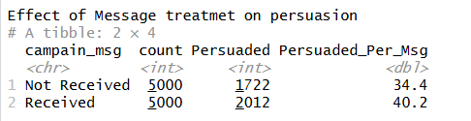
Party affiliation shows clear differences in voter persuasion. Democrats make up the largest group in the dataset at 47.4% of voters, followed by Republicans at 28.6%, Independents at 22.8%, and Other voters at 1.26%. Message distribution is fairly balanced across parties, with about half of each party group receiving the campaign message. Democrats had the highest overall persuasion rate at 54.9%, and among Democrats who received the message, 58.1% were persuaded. Independents also showed a moderate persuasion rate, with 40.1% persuaded overall and 43.9% persuaded among those who received the message. Republican voters had the lowest persuasion rate, with only 5.57% persuaded overall and 7.67% persuaded among those who received the message. This suggests that party affiliation is strongly related to persuasion, and the campaign message appears more effective among Democrats and Independents than among Republicans.
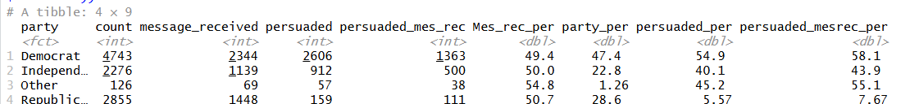
Age ranges from 18 to over 90 years, with a median of 50. We have good representation across all age groups: young adults (18-30), middle-aged (31-60), and seniors (60+). Gender has split of 57% female and 43% male.
Neighborhood income ranges from under $40,000 to over $120,000. College education rates vary from single digits to over 60%. This diversity lets us examine whether economic and educational differences affect how voters respond to campaign messages.
Candidate 1 support shows a strong relationship with voter persuasion. Most voters were in the S category, representing 53.8% of the dataset, but this group had a very low persuasion rate of only 7.86%. Among voters in this group who received the message, only 9.51% were persuaded. In contrast, voters in the L and U categories were much more persuadable. The L group had an overall persuasion rate of 74.6%, and this increased to 77.7% among those who received the message. Similarly, the U group had a persuasion rate of 69.0%, increasing to 73.4% among message receivers. This suggests that voters who are less firmly aligned or uncertain toward Candidate 1 are much more likely to be persuaded than voters who strongly support Candidate 1.
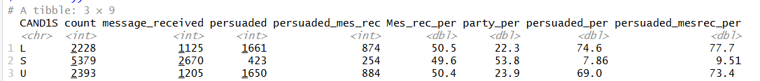
Candidate 2 support also shows meaningful differences in persuasion. The largest group was the S category, making up 79.7% of voters, but this group had a lower persuasion rate of 32.8%, increasing slightly to 35.3% among those who received the message. The L group, although smaller at 13.6% of voters, showed the highest persuasion rate at 63.5%, and 68.2% of message-received voters in this group were persuaded. The U group represented 6.71% of voters and had a moderate persuasion rate of 38.7%, increasing to 42.8% among voters who received the message. Overall, voters with lower support for Candidate 2 appear to be the most persuadable, while strong Candidate 2 supporters are less responsive to persuasion.
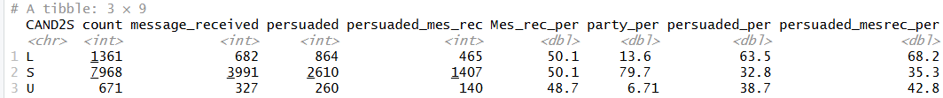

Correlation Analysis
We examined how variables relate to each other and to voter persuasion. No single variable shows a very strong relationship with persuasion, which tells us we need to combine multiple factors in our models to make accurate predictions.
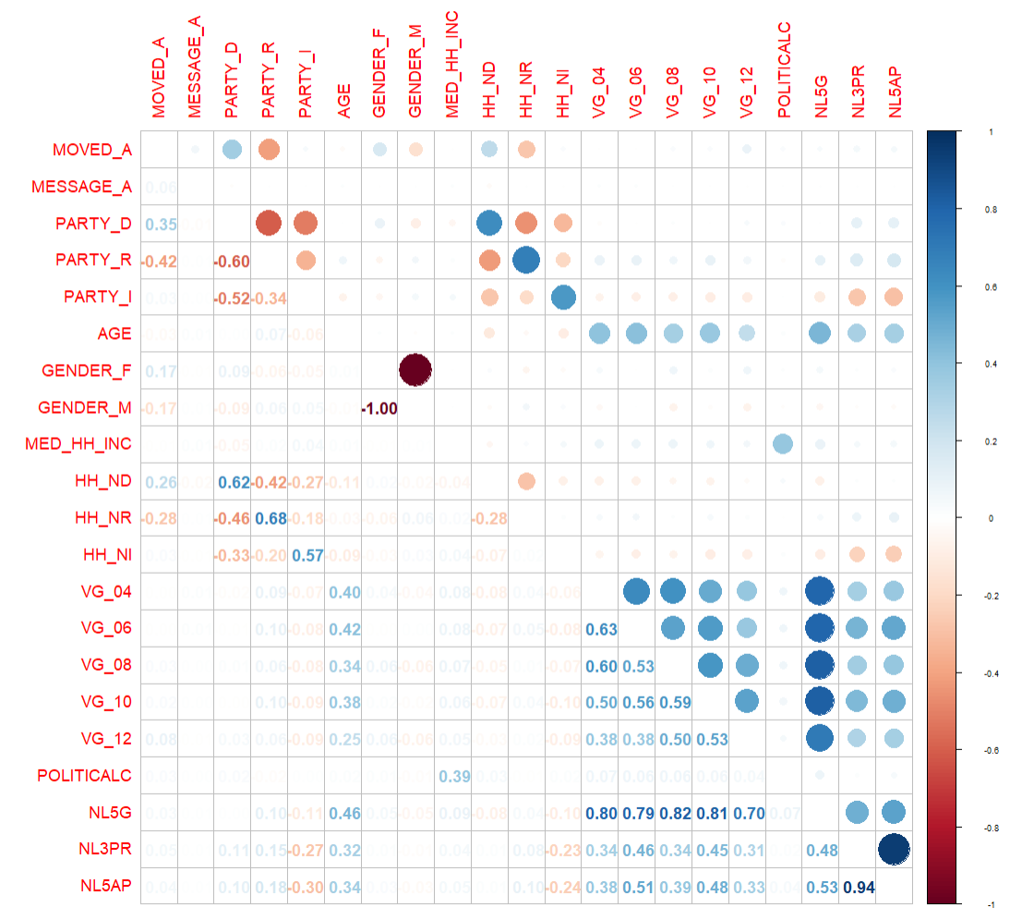

Age and gender show weak connections to persuasion. Party affiliation shows a clearer relationship, which is why we examined how messages work differently for Democrats, Republicans, and Independents.
Voting history variables are correlated with each other because people who vote in one election tend to vote in others. To simplify this, we created a single voting frequency score that counts how many of the last five elections each person voted in.
Number of Household Republicans, Democrats, Independents are correlated with party affiliations. So, we can ignore these variables for prediction as they become redundant.
Correlation analysis makes sense on continuous attributes as correlation coefficients are not applicable to categorical or binary indicators. Hence, several binary variables have low or no correlation with the target variable and do not give clear relationship or influence of these variables on the target variable.

Predictor Analysis and Variable Relevance
With over 80 variables available, we selected 10 that are most relevant:
Treatment variable: MESSAGE_A (whether the voter received the campaign message)
Demographics: Age, gender
Political identity: Party affiliation (Democrat, Republican, Independent)
Voting behavior: Voting frequency score
Neighborhood: Median income
Baseline attitudes: Initial support levels for each candidate
This focused set keeps our models interpretable while keeping the key factors that influence persuasion (who voters are, their political identity, their voting habits, where they live, and their starting preferences). This approach ensures that the models are transparent and predictable, which makes it easier for the campaign staff.

Dimension Reduction
Dimension reduction techniques were considered but not used in the analysis. Techniques like principal component analysis involve the creation of abstract components that are difficult to relate to the campaign decision-making process.
The client wants transparency in the insights generated, the importance of maintaining the meaning of the attributes was given more importance. Each of the attributes used in the model corresponds to an attribute of the voters or campaign-related factors.
The total number of predictors used in the model was limited, which reduced the need to use dimension reduction techniques. Hence, the entire set of predictors was used in the model.

Data Engineering and Transformation
Before modeling, the data was prepared to ensure consistency, interpretability, and suitability for modeling. Only transformations that were necessary for clarity and model stability were applied.
Categorical attributes such as gender, party affiliation, candidate support levels, and message exposure indicators were treated as categorical variables to preserve their meaning.
A new variable vote count was created to represent the participation of voters in elections happened in previous years.
Continuous attributes, including age, median household income, and voting history (vote count), were kept in numeric form. These variables represent quantities where relative magnitude is meaningful and informative for persuasion modeling. For the logistic regression model, numeric variables were standardized to ensure comparability across predictors and to improve numerical stability. Standardization was not applied for the decision tree model, as tree-based methods are not sensitive to variable scale and benefit from retaining original units for interpretability.
Redundant variables and mutually exclusive indicators were reviewed to avoid multicollinearity. In cases where multiple indicators represented the same conceptual attribute, reference categories were implicitly established to ensure stable and interpretable model estimates. (like household political affiliations, voting history, ,MESSAGE_A_REV)

Data Partitioning Methods
To assess the performance of the models objectively, the dataset was split into training sets and testing sets. The training sets were used for the estimation of the supervised models.
The dataset was split into 70% training sets and 30% testing sets. This is important since it provides enough data for the estimation of the models while at the same time providing enough data for the evaluation of the models.
The partitioning was done randomly but in a way the distribution of the persuasion outcome was preserved in both sets. This is important since it allows the evaluation of the models objectively. Both the training and test data sets have similar distribution of the target variable (63% of not persuaded and 37% of persuaded voters).

Model selection and justification
Two supervised learning models were chosen to achieve the objectives of the project: logistic regression and a decision tree.
The logistic regression model was selected as the main explanatory model because of its interpretability. In this model, each predictor’s influence on target variable can be shown as it provides estimates of the direction and magnitude of each, which enables the explanation of the relationship between demographic, political, and behavioral variables and voter persuasion in a clear and concise manner. This model is ideal for sharing knowledge with non-technical audiences and strategic decision-making.
The decision tree model was selected as an alternative approach to model interaction effects and segmentation patterns of voters that are not easily captured by linear models. Decision trees are intuitive models that automatically identify attribute combinations that define persuadable groups of voters and can be easily translated into actionable rules for campaign staff.

Model fitting and performance evaluation
Two supervised learning models were trained and tested to achieve the goals of the campaign: a logistic regression model and a decision tree model.

Logistic Regression Model Performance
The logistic regression model was trained on the data to estimate the association between voter attributes and persuasion. The model generated statistically significant and interpretable results consistent with the campaign's strategic goals. Below are the results,
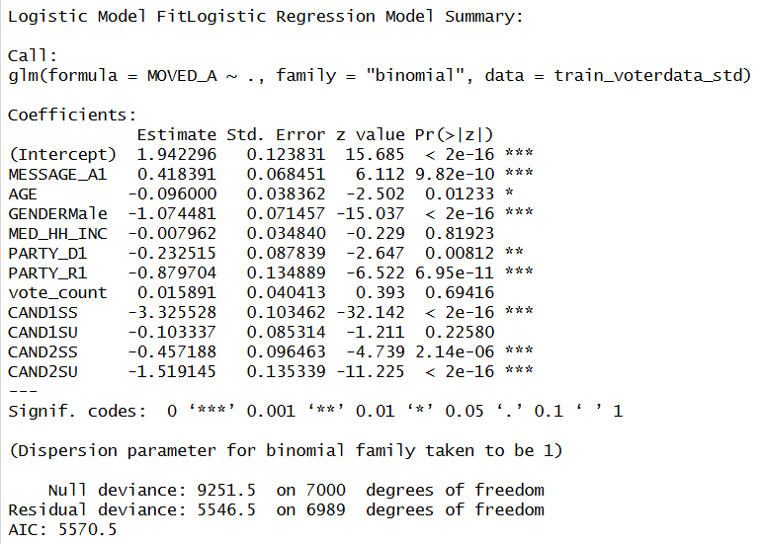
- Voters who were exposed to the campaign message had a higher probability of being persuaded than those who were not exposed to the message. This confirms that campaign outreach has a measurable positive effect.
- Age was negatively associated with persuasion, suggesting that younger voters were more receptive to persuasion.
- Gender differences were large, with male voters being significantly less likely to be persuaded than female voters. Female voters appear more responsive to campaign outreach, suggesting tailored messaging by gender may be beneficial.
- Median household income does not affect persuasion likelihood once other factors are considered.
- Both Democrats and Republicans are less persuadable than Independents. Republicans show a much stronger resistance compared to Democrats. Independent voters represent the most persuadable segment and should be prioritized for outreach.
- Vote count also is not significant and does not have any effect on persuasion.
- Candidate support is the strongest predictor in the model. Voters with strong prior candidate support were less likely to be persuaded, while undecided voters showed higher responsiveness to campaign outreach. This suggests that campaign outreach is most effective among undecided voters.
This model is evaluated using the test data set with a probability cutoff of 0.5, the logistic regression model achieved the following test-set performance:
Accuracy: 84.96 percent
Sensitivity (Recall): 87.32 percent
Specificity: 83.56 percent
Balanced Accuracy: 85.44 percent
The model correctly identified 87.3 percent of persuadable voters, which aligns closely with the campaign’s primary objective of minimizing missed persuasion opportunities. While some non-persuadable voters were incorrectly classified as persuadable, this trade-off is acceptable given the relatively lower cost of contacting a non-responsive voter compared to missing a persuadable one.
The Area Under the ROC Curve (AUC) for the logistic regression model was 0.8939. This value shows that the model does a very good job of distinguishing between voters who are likely to be persuaded and those who are not. In practical terms, the model can reliably rank voters by their likelihood of persuasion, which makes it useful for deciding whom to prioritize in campaign outreach.
Overall, the logistic regression model provided stable predictive performance and clear insights into the factors driving voter persuasion, making it well suited for strategic analysis and stakeholder communication.

Logistic Regression Model Performance
Based on the results of the logistic regression, two interaction terms were added to model to understand the effect of campaign message on voter segments.
The terms included were MESSAGE x PARTY_R and MESSAGE_A x CAND2S. These are included as PARTY_R and CAND2S are two voter segments that are statistically more significant and have higher influence on the persuasion variable (MOVED_A). Below are the results,
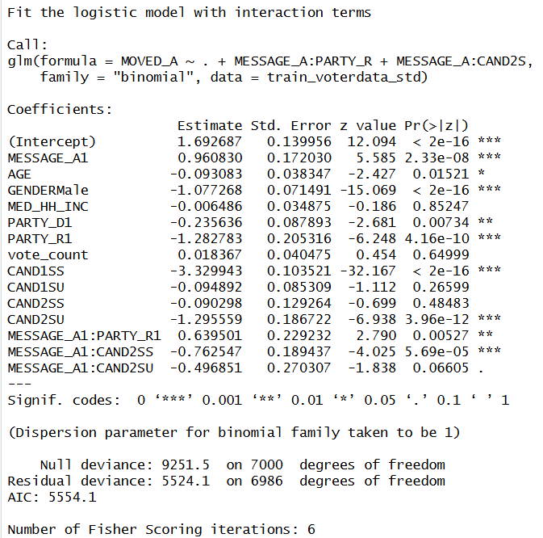
Interestingly, the interaction between MESSAGE_A and PARTY_R1 has a significant positive impact on persuasion. And the MESSAGE_A and CAND2SS interaction has strong negative impact on persuasion.
Similarly, this model is also evaluated using the test data and 0.5 cutoff, the logistic regression model with interaction terms has the below test set performance:
Accuracy: 85.23 percent
Sensitivity (Recall): 88.21 percent
Specificity: 83.45 percent
Balanced Accuracy: 85.83 percent
There is only slight increase in accuracy and sensitivity. Which may not be considerable, but Interaction modeling is more about understanding the effect of treatment than increasing the accuracy dramatically.
Also, there is not much change in the AUC with the addition of interaction terms. Though this model has no significant improvement in the prediction performance, the idea is to know if the campaign message has effect on different segments as part of the business goal. This model clearly achieves that and tells that certain voter segments like republicans are effected by the campaign message even though they were resistant to persuasion.

Decision Tree Model Performance
A decision tree model was then built using the unstandardized training data set to model non-linear relationships and interactions between predictors. The model used mainly candidate support, party affiliation, gender, and age as bases for segmentation.
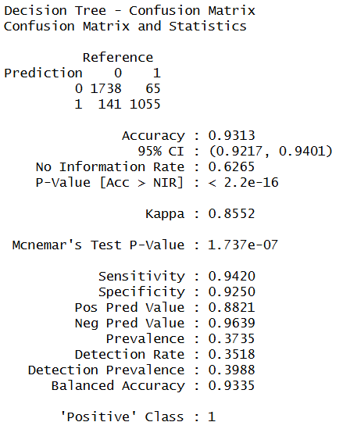
The decision tree model with default settings showed high performance in predicting the test set data with an accuracy rate of 93.13 percent and a balanced accuracy rate of 93.35 percent. The model showed high levels of effectiveness in detecting persuadable voters with sensitivity and specificity rates of 94.20 percent and 92.50 percent, respectively.
However, the model had some small terminal nodes with near-perfect classification. This could mean the model is overfitting and could be fitting noise rather than general patterns. Overfitting is a problem because the model may not perform well on new/unknown data.
The complexity parameter (CP) is used to control the complexity of the decision tree by penalizing additional splits that do not significantly impact the predictive accuracy of the decision tree. Which means that smaller CP values allow the tree to be deeper, while higher CP values result in a simpler decision tree.
From the cross-validation results, the smallest cross-validated error is achieved when the CP is equal to 0.01, which is also the default value of CP used in the decision tree algorithm. This implies that the fully grown tree had the best predictive accuracy on the training data. However, this tree had very small terminal nodes with perfect classification, which is another sign of overfitting.

Decision Tree Pruning and Model Evaluation
To reduce overfitting, cost complexity pruning with cross-validation and the 1-standard-error (1-SE) rule was implemented. Instead of selecting the most complex tree with the lowest cross-validation error, a simpler tree with a performance within one standard error of the lowest error was selected.
Which means that selecting a slightly larger CP value results in reduced complexity by generating a simpler tree with less rules. Further constraints like increasing number of cross validations and minimum bucket size were implemented to ensure the terminal nodes were representative of significant voter segments and prevents smaller nodes.
The pruned decision tree still determined the candidate’s support and party affiliation are the most significant features while reducing the model’s complexity.

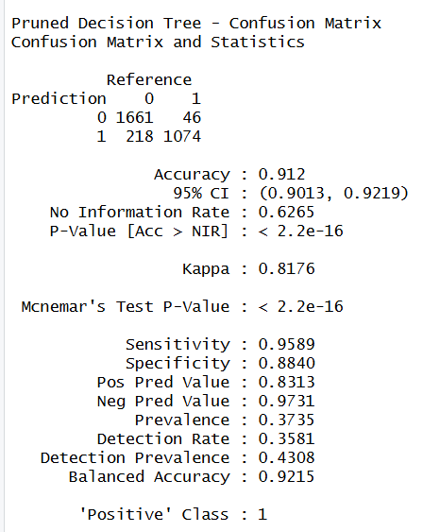
In terms of accuracy, the pruned decision tree performed with an accuracy of 91.20 percent and a balanced accuracy of 92.15 percent on the test dataset. The sensitivity of the model increased to 95.89 percent, which is an exceptional result for a model attempting to identify persuadable voters.
The specificity of the model remained high at 88.40 percent, confirming that the model can limit the number of voters being targeted. As expected, the accuracy of the model reduced slightly from the unpruned decision tree, but the pruned model has the advantage of increased generic decision rules for better operational efficiency.

Report on Models’ Performance
To support the campaign’s objective of data-driven outreach, four supervised models were evaluated: a logistic regression model, a logistic regression with interaction terms model, an unpruned decision tree, and a pruned decision tree. All models were trained on 70% of the data and tested on the remaining 30% to ensure objective performance evaluation.

Logistic Regression Performance
The logistic regression model had an overall accuracy of 84.96% on the test set. It was able to correctly classify 87.32% of the actual persuaded voters (sensitivity) and 83.56% of the actual non-persuaded voters (specificity). The AUC value of 0.8939 is a strong indicator of distinguishing between the two groups of voters.
The logistic regression model is interpretable and has clear directionality. Receiving Message A is a significant factor in being persuaded, while being male, Republican, and having a strong support towards Candidate 1 are all significant factors in not being persuaded. However, this model does not clearly tell how the campaign message effects different factors of voters.

Logistic Regression with Interaction Terms Performance
Including interaction terms of MESSAGE_A X PARTY_R and MESSAGE_A x CAND2S improved the model slightly. Accuracy increased to 85.23%, sensitivity to 88.21%, and AUC to 0.8960.
The interaction term MESSAGE_A x PARTY_R was significant (p = 0.005), indicating that Republican voters react differently to the campaign message than other voters. Although Republicans are harder to persuade overall, when they do receive the message, its impact is stronger than expected.
The interaction term MESSAGE_A x CAND2SS was also significant, indicating that voters with a strong favorable sentiment towards Candidate 2 actually become less convinced when they receive the message. These are important considerations for targeted campaign messaging.
This model answers our research question if the message campaign has effect on different voter segments.

Decision Tree Performance (Unpruned)
The decision tree had the highest accuracy of 93.13%, with a sensitivity of 94.20% and specificity of 92.50%.
However, this model showed signs of overfitting. The model presented a very complex tree structure, memorizing patterns in the data, including small leaf nodes (some with only 1 error out of thousands of observations).
Although these results appear impressive, this model would likely perform less accurately on new, unseen data of voters. It has five predictors for decision split, CAND1S, CAND2S, PARTY_D, AGE, and GENDER.

Decision Tree Performance (Pruned)
To address the problem of overfitting, the decision tree was pruned with a complexity parameter (cp = 0.0137) according to the 1-SE rule, the number of folds in cross-validation was raised to 20, and a minimum bucket size of 100 was required.
The pruned tree resulted in an accuracy of 91.20%, sensitivity of 95.89%, and specificity of 88.40%.
Although it has a slightly lower accuracy than the unpruned tree, it is a more generalizable model. It only uses CAND1S, CAND2S, and PARTY_D to predict the target variable, which is more interpretable and useful.

Report on Comparison and Evaluation of Selected Models
The four models are contrasted in the table below on the three important performance measures. Each of the performance measures highlights a different dimension of model quality, all of which are important in the context of a campaign.
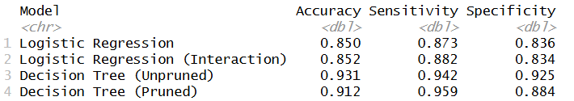
The unpruned decision tree has the highest accuracy (93.13%), although, as explained, this is distorted by overfitting. Nevertheless, the pruned decision tree (91.20%) is still better than the two logistic regression models (~85%) in terms of accuracy. However, accuracy is not a particularly informative measure of model quality if the aim is to persuade a subset of voters rather than the whole population.
Sensitivity highlights the ability of the model to correctly identify voters who can be persuaded. The pruned decision tree is the best model in this regard at 95.89%, indicating that it misses fewer persuadable voters. This is particularly important if the campaign has limited funds and the cost of missing a persuadable voter is high. The logistic models, although not as good (~87-88%), are still very effective.
Specificity indicates the ability of the model to avoid contact with non-persuadable voters. The unpruned tree has the highest specificity of 92.50%, followed by the pruned tree with a specificity of 88.40%. The logistic models are fairly similar to each other in terms of specificity (~83-84%). A campaign that wishes to avoid wasted contact efforts would be interested in higher specificity.

Which Model is Best?:
There is no single best model, the right choice depends on what the campaign needs to accomplish.
- If the goal is to understand what drives persuasion and explain findings to stakeholders: Logistic Regression with Interaction Terms is preferred. It is transparent, statistically interpretable, and reveals how message effects differ across party lines and candidate sentiment groups.
- If the goal is to rank and prioritize voters for outreach when resources are limited: the Pruned Decision Tree is the stronger choice. Its high sensitivity ensures that persuadable voters are not missed, and the simple rule-based structure makes it easy to apply in the field.
- The Unpruned Decision Tree should not be used for real-world predictions due to its overfitting risk, even though its metrics appear the strongest.
The models also complement each other well. The logistic model can answer 'why' a voter is likely to be persuaded, while the decision tree can answer 'who' to prioritize. For example, if a campaign can only contact 25% of voters, the predicted probabilities from the logistic model or the tree-based rules from the pruned decision tree can be used to rank all voters and select the top tier for outreach. The choice between models depends on whether the campaign values an easy-to-rank probability score (logistic) or a clean set of interpretable voter segments (decision tree).

Report on Observations and Conclusions
From the analysis, we can conclude the following, which will directly impact the strategy of the campaign:
- The models have verified that "Message A" is a strong predictor of voter persuasion. This message should be maintained as part of the communications strategy.
- The data indicates that voters' behavior is strongly tied to their current assessment of the candidates. For instance, voters who favor "Candidate 1" (CAND1S) but are undecided or less sure about "Candidate 2" (CAND2S) are a high-opportunity segment to target.
- The campaign has indicated that they need to differentiate among voters since they have limited resources. If the leadership of the campaign can only reach 25% of the total voter base, our models will help them "rank" the entire voter file.
- Rather than reaching out to people at random, we can assign a persuasion score to each person.
- The campaign should then concentrate its 25% of effort solely on those people who have the highest scores, those that the model has determined have the highest probability of changing from "No" or "Undecided" to "Yes."
- Our Decision Tree offers a roadmap for outreach. For example, one of our most powerful "Yes" groups (89% chance of movement) is comprised of voters who favor Candidate 1 but are also undecided or leaning towards Candidate 2. These are the voters that should be targeted on a daily basis.
Final Recommendation:
Using the Pruned Decision Tree as the primary means of voter targeting is recomended. It offers a high level of technical quality combined with the transparency necessary for senior leadership to explain their spending and outreach choices to stakeholders.

